September 2020
 | Monday | Tuesday | Wednesday | Thursday | Friday | Daily Activities
 |  | 1. Thesaurus Day | 2. Good Neighbor Day | 3. Eye Health Day  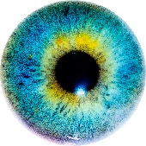  by Unknown Author is licensed under CC BY-SA | 4.Trail Mix Day | 6:00-9:00am  Arrivals and personal care/ Devotion/ Current Events  7:30-9:30am  Breakfast/ Morning Snacks
 | - CLOSED | - Take a Wild Guess Day! | 9. Cheese Pizza Day  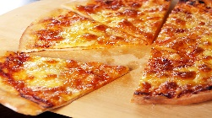 | 10. Book Lovers Day  Nail Care | 11. Dear Diary Day  . | 9:45-10:30  Chair aerobics/ Morning Walk  10:30-12:00  Morning Craft/ Activity
 | 14. Teddy Bear Day | 15. Piano Instruction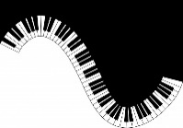 | 16. Chocolate Milk Shake Day | 17. Peanut Day  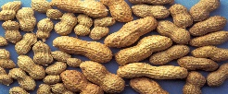  Nail Care & Massage | 18.Aromatherapy Day | 12:00-1:00 Lunch (see menu)  1:15-2:00  Rest time, weekly Medical checks, Afternoon Walk
 | 21. Rock Collection Day  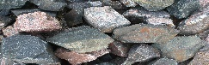  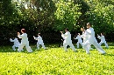  Tai Chi | 22. Gratitude Day! | 23. Bowling | 24. Down on the Farm  Nail Care & Massage | 25. Coffee Day | 2:00-3:00pm afternoon activity (See Calendar)  Nail care and Massage  3:00-4:00 Afternoon Snack/ Rest
 | 28. Let’s Laugh Day | 29. Comic Book Day | 30. Love note Day |  |  | 4:00-6:30  Choice of activity/ Departure

