November 2021
 | Monday | Tuesday | Wednesday | Thursday | Friday | Daily Activities
 | 1.National Author’s Day | 2. U.S. General Election Day | 3. National Stress Awareness Day | 4. King Tut Day  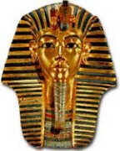 | 5. Fun Friday: Jersey Day  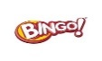 | 6:00-9:00am  Arrivals and personal care/ Devotion/ Current Events  7:30-9:30am  Breakfast/ Morning Snacks
 | 8.Cornucopia Craft | 9. World Freedom Day  Cornucopia Craft | 10. USMC Day  Cornucopia Craft | 11. Veteran’s Day  Cornucopia Craft | 12. Fun Friday:  Cornucopia Craft | 9:45-10:30  Chair aerobics/ Morning Walk  10:30-12:00  Morning Craft/ Activity
 | 15. America Recycles Day | 16. National Button Day | 17. Hiking Day | 18. Diabetes Awareness | 19. Fun Friday: National Play Monopoly Day | 12:00-1:00 Lunch (see menu)  1:15-2:00  Rest time, weekly Medical checks, Afternoon Walk
 | 22. Day of Listening  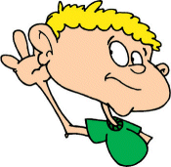 | 23. Give Thanks  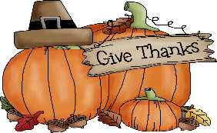 | 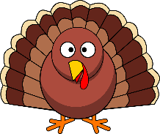  24. Tom Turkey Day | 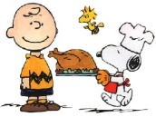  25. Thanksgiving Day  Closed: Enjoy Your Family | 26. Black Friday  Closed: Enjoy Your Family | 2:00-3:00pm afternoon activity (See Calendar)  Nail care and Massage  3:00-4:00 Afternoon Snack/ Rest
 | 29. Square Dance Day | 30. National Mason Jar Day  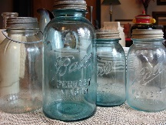  . |  |  |  | 4:00-6:30  Choice of activity/ Departure

