March 2023
Monday |  | Tuesday |  | Wednesday | Thursday | Friday | Saturday | Daily Activities
 |  |  |  | - World compliment Day  Senior Expo | 2. Dr. Seuss’s Birthday |  | 4. Play Outside Day 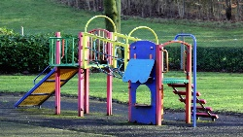 | 6:00-9:00am  Arrivals and personal  care/ Devotion/  Current Events  7:30-9:30am  Breakfast/  Morning Snacks
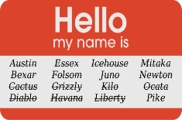  6. Fun  facts about Names  Day |  | 7. National Cereal Day |  | 8. Grammar Day  Dance | 9. Plant a Flower Day  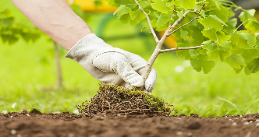 | 10. Day of Awesomeness | 11. National Dream Day  This Photo by Unknown Author is licensed under CC BY | 9:45-10:30  Chair aerobics/  Morning Walk  10:30-12:00  Morning Craft/ Activity
13. National Jewel Day |  | 14. |  | 15. Shoe the world day  Dance | 16. National Panda Day | 17. St Patrick’s Day | 18. National Quilting Day | 12:00-1:00 Lunch  (see menu)  1:15-2:00  Rest time,  weekly medical checks, Afternoon Walk
20. First Day of Spring |  | 21. International Day of Forests |  | 22. World Water Day  Dance | 23. Puppy Day | 24. Goof Off Day  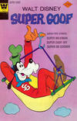 | 25. Tolkien Reading day  This Photo by Unknown Author is licensed under CC BY | 2:00-3:00pm afternoon activity  (See Calendar)  Nail care and  Massage  3:00-4:00  Afternoon Snack/ Rest
27. World Theater Day |  | 28. Make up your own Holiday |  | 29. Earth Hour | 30. Walk in the  Park Day | 31. Eiffel tower Day |  | 4:00-6:30  Choice of activity/ DepartureC

